UNIT-2

Data : It is information that must be processed and stored in a computer. Eg: 23, 23.00, KMIT, Large Texts , Photos , Music Files , etc.

Structure : It specifies the logical relationship between various data elements and how they are kept in memory.

The structure has an impact on the efficiency of data operations like Searching ,Sorting ,Min, Max, Avg, Mean ,Neighbors , Inserting , Deleting , etc.

It is a framework organizing and manipulating data, making information management and analysis easier.They also enable the development of efficient data-processing algorithms, allowing difficult issues to be solved in a reasonable amount of time.

What is a Data Structure?

Data Structure = Data + Structure

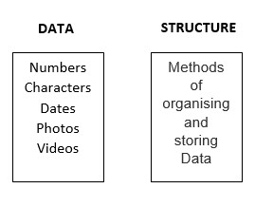

What is the need of Data Structure?

Improved Time Complexity: Using appropriate data structures can lead to better time complexity, making it possible to solve problems more quickly. For example, searching for an element in a sorted array is faster than searching for it in an unsorted array.

Better Space Complexity: Data structures can help to reduce the amount of memory needed to store data. For example, using a linked list instead of an array can reduce the amount of memory needed to store the same data.

Efficient Data Retrieval: Data structures make it easier to retrieve specific data efficiently. For example, a hash table can retrieve data in constant time, while searching through an unsorted array takes linear time.

Better Data Management: Data structures make it easier to manage and manipulate data. For example, a stack can be used to implement an undo functionality in an application.

Solving Complex Problems: Data structures can provide the foundation for efficient algorithms, making it possible to solve complex problems in a reasonable amount of time. For example, graph algorithms can be used to find the shortest path between two points or to find the minimum spanning tree of a graph.

Increased Data Security: Data structures can be designed to provide additional security features, such as data encryption and protection against unauthorized access.

Characteristics of Data Structure:

Representation of Data: a way of representing data in a computer's memory, making it possible to store, manipulate, and access data efficiently.

Access Techniques: Different data structures provide different techniques for accessing data stored within them, such as random access or sequential access.

Storage Organization: Data structures define the organization of data in memory, such as linear or hierarchical organization.

Insertion and Deletion Operations: Different data structures support different methods for adding and removing elements, such as insertion at the end or deletion from the front.

Time and Space Complexity: Data structures can have different time and space complexities, depending on the operations they support and the way they organize data.

Adaptability: Some data structures are more adaptable to certain types of data and operations than others. For example, a stack is more suitable for problems that require Last-In-First-Out (LIFO) behavior, while a queue is better suited for problems that require First-In-First-Out (FIFO) behavior.

Flexibility: Different data structures have different degrees of flexibility, such as the ability to dynamically grow or shrink in size, or the ability to efficiently insert or delete elements in the middle.

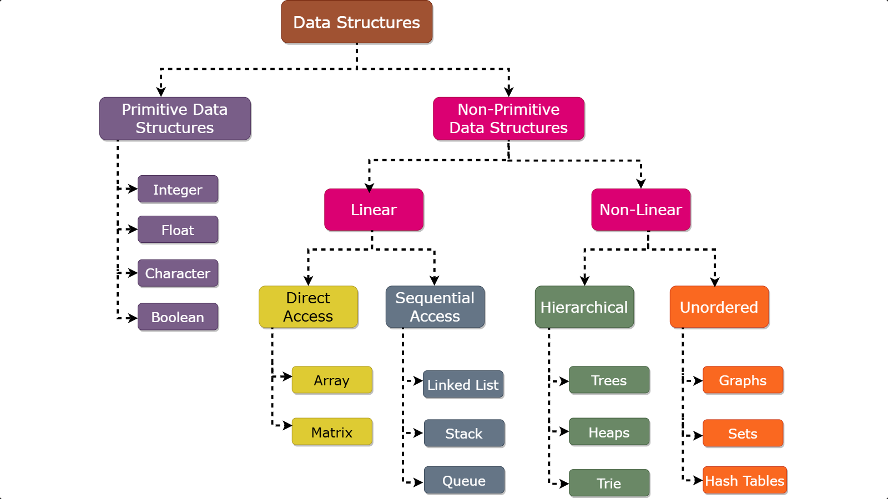

Primitive

Primitive Data Structures:

These are the basic data types provided by a programming language.

Examples include integers, floats, characters, and Booleans.
- They store single values directly in memory.
- They have a fixed size, which is predefined by the language, making them memory-efficient
- Operations are basic, such as arithmetic and logical operations.
- They are allocated on the stack, allowing for fast and straightforward access

Non- Primitives

Non-primitive data structures are complex and built using primitive data types and/or other non-primitive data types. Examples include arrays, lists, stacks, queues, trees, and graphs
- They can store collections of data elements.
- Their size can be dynamic and can vary during runtime. However, static arrays are an exception.
- Support a wide range of complex operations specific to the data structure, such as insertion, searching, and sorting
- Typically allocated on the heap, with a reference to the memory stored in the stack. This allows them to handle dynamic data sizes and more complex data organization

Recursion
Recursion in C++ is a technique in which a function calls itself repeatedly until a given condition is satisfied. In other words, recursion is the process of solving a problem by breaking it down into smaller, simpler sub-problems.

Syntax Structure of Recursion
return_type recursive_func {
....
// Base Condition
// Recursive Case
....
}

Recursive Function
A function that calls itself is called a recursive function. When a recursive function is called, it executes a set of instructions and then calls itself to execute the same set of instructions with a smaller input. This process continues until a base case is reached, which is a condition that stops the recursion and returns a value.

Base Condition
The base condition is the condition that is used to terminate the recursion. The recursive function will keep calling itself till the base condition is satisfied.

Recursive Case
Recursive case is the way in which the recursive call is present in the function. Recursive case can contain multiple recursive calls, or different parameters such that at the end, the base condition is satisfied and the recursion is terminated.

Example of C++ Recursion
The following C++ program illustrates how to perform recursion.
/ C++ Program to calculate the sum of first N natural
// numbers using recursion
#include<iostream>
usingnamespacestd;

intnSum(intn)
{
// base condition to terminate the recursion when N = 0
if(n==0){
return0;
}

// recursive case / recursive call
intres=n+nSum(n-1);

returnres;
}

intmain()
intn=5;

// calling the function
intsum=nSum(n);

cout<<"Sum = "<<sum;
return0;
}
Output
Sum = 15

In the above example,
Recursive Function: nSum() is the Recursive Function
Recursive Case: The expression, int res = n + nSum(n – 1) is the Recursive Case.
Base Condition: The base condition is if (n == 0) { return 0;}

Working of Recursion in C++
To understand how C recursion works, we will again refer to the example above and trace the flow of the program.
1. In the nSum() function, Recursive Case is
int res = n + nSum(n - 1);
2. In the example, n = 5, so as nSum(5)’s recursive case, we get
int res = 5 + nSum(4);
3. In nSum(4), the recursion case and everything else will be the same, but n = 4. Let’s evaluate the recursive case for n = 4,
int res = 4 + nSum(3);
4. Similarly, for nSum(3), nSum(2) and nSum(1)
int res = 3 + nSum(2); // nSum(3)
int res = 2 + nSum(1); // nSum(2)
int res = 1 + nSum(0); // nSum(1)
Let’s not evaluate nSum(0) and further for now.
5. Now recall that the return value of the nSum() function in this same integer named res. So, instead of the function, we can put the value returned by these functions. As such, for nSum(5), we get
int res = 5 + 4 + nSum(3);
6. Similarly, putting return values of nSum() for every n, we get
int res = 5 + 4 + 3 + 2 + 1 + nSum(0);
7. In nSum() function, the base condition is
if (n == 0) {
return 0;
}
which means that when nSum(0) will return 0. Putting this value in nSum(5)’s recursive case, we get
int res = 5 + 4 + 3 + 2 + 1 + 0;
= 15
8. At this point, we can see that there are no function calls left in the recursive case. So the recursion will stop here and the final value returned by the function will be 15 which is the sum of the first 5 natural numbers.

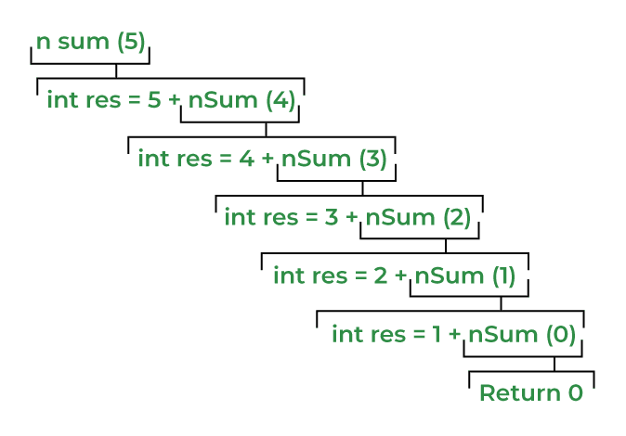

Recursion is mainly two types Direct recursion and Indirect Recursion
Direct Recursion: These can be further categorized into four types:
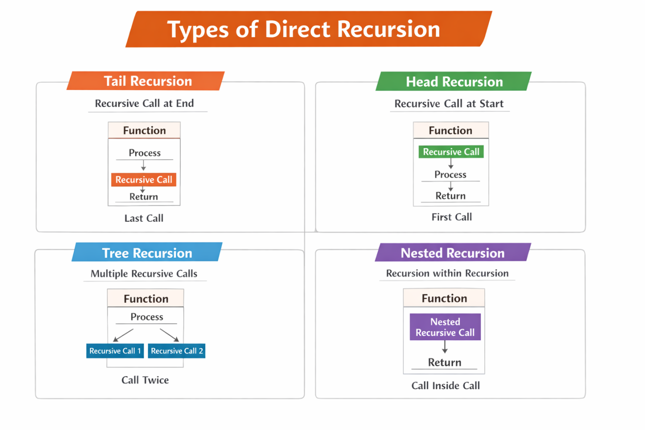
Tail Recursion: If a recursive function calling itself and that recursive call is the last statement in the function then it’s known as Tail Recursion. After that call the recursive function performs nothing. The function has to process or perform any operation at the time of calling and it does nothing at returning time.

// Code Showing Tail Recursion
#include <iostream>
using namespace std;

// Recursion function
void fun(int n)
{
if (n > 0) {
cout << n << " ";

// Last statement in the function
fun(n - 1);
}
}

// Driver Code
int main()
{
int x = 3;
fun(x);
return 0;
}

// This code is contributed by shubhamsingh10
Output:
3 2 1
Consider the example by tracing tree of recursive function. That is how the calls are made and how the outputs are produced.
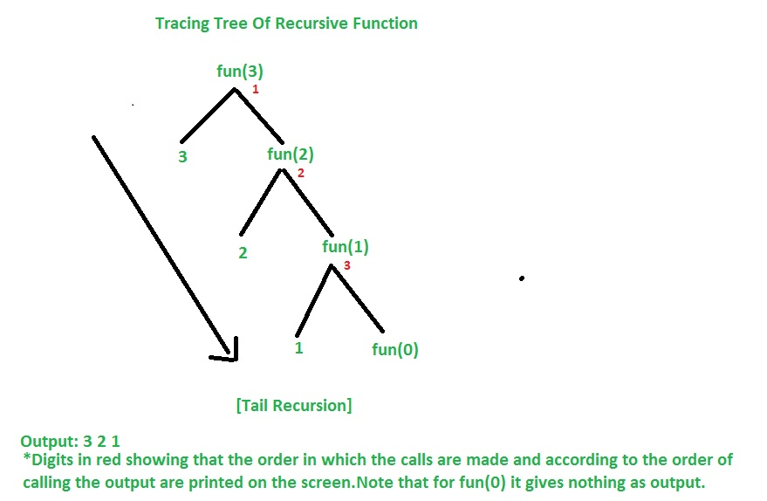
Time Complexity For Tail Recursion : O(n)
Space Complexity For Tail Recursion : O(n)
Note: Time & Space Complexity is given for this specific example. It may vary for another example.
Let’s now converting Tail Recursion into Loop and compare each other in terms of Time & Space Complexity and decide which is more efficient.
// Converting Tail Recursion into Loop
#include <iostream>
using namespace std;

void fun(int y)
{
while (y > 0) {
cout << y << " ";
y--;
}
}
Driver code
int main()
{
int x = 3;
fun(x);
return 0;
}
Output
3 2 1
Time Complexity: O(n)
Space Complexity: O(1)
Note: Time & Space Complexity is given for this specific example. It may vary for another example.
So it was seen that in case of loop the Space Complexity is O(1) so it was better to write code in loop instead of tail recursion in terms of Space Complexity which is more efficient than tail recursion.

Head Recursion: If a recursive function calls itself before performing any other operation in the function, then it is known as Head Recursion.
In this type, the recursive call occurs at the beginning of the function. The function performs its processing after the recursive call returns. That means the operations are done at returning time rather than at calling time.

Example :
#include <iostream>
using namespace std;

void headRecursion(int n) {
if (n == 0)
return;

headRecursion(n - 1); // first
cout << n << " ";
}

int main() {
headRecursion(5);
return 0;
}

Tree Recursion
If a recursive function calls itself more than once in the same function, then it is known as Tree Recursion.
In this type, each function call generates multiple recursive calls, forming a tree-like structure of function calls. Because of multiple calls, the number of function executions increases rapidly.
Example :
#include <iostream>
using namespace std;
void treeRecursion(int n) {
if (n <= 0)
return;
cout << n << " ";
treeRecursion(n - 1);
treeRecursion(n - 1);
}
int main() {
treeRecursion(3);
return 0;
}

Nested Recursion
If a recursive function passes a recursive call as an argument to another recursive call, then it is known as Nested Recursion.
In this type, the function calls itself inside another recursive call, creating a nested structure. The inner recursive call is executed first, and its result is then used by the outer recursive call.
Example :
#include <iostream>
using namespace std;
int nestedRecursion(int n) {
if (n > 100)
return n - 10;
else
return nestedRecursion(nestedRecursion(n + 11));
}
int main() {
cout << nestedRecursion(95);
return 0;
}

Type | Key Feature
Tail Recursion | Recursive call at the end.
Head Recursion | Recursive call at the beginning.
Tree Recursion | Multiple recursive calls.
Nested Recursion | Recursive call inside another recursive call.

Indirect Recursion: In this recursion, there may be more than one functions and they are calling one another in a circular manner
.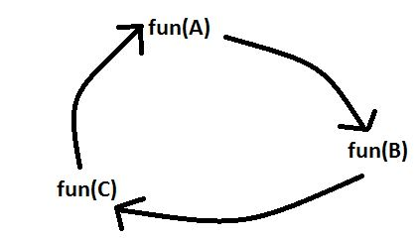

From the above diagram fun(A) is calling for fun(B), fun(B) is calling for fun(C) and fun(C) is calling for fun(A) and thus it makes a cycle.
Example:
// C++ program to show Indirect Recursion
#include <iostream>
using namespace std;
void funB(int n);
void funA(int n)
{
if (n > 0) {
cout <<" "<< n;

// fun(A) is calling fun(B)
funB(n - 1);
}

}
void funB(int n)
{
if (n > 1) {
cout <<" "<< n;

// fun(B) is calling fun(A)
funA(n / 2);
}
}

Driver code
int main()
{
funA(20);
return 0;
}

Output
- 9 9 8 4 3 1

Data Abstraction

Data abstraction in C++ means providing only the essential details to the outside world and hiding the internal details, i.e., hiding the background details or implementation. Abstraction is a programming technique that depends on the separation of the interface and implementation details of the program.

In C++, abstraction is mainly achieved using:
- Classes
- Access Specifiers (private, protected, public)
- Abstract Classes
- Interfaces

Data Abstraction Using Classes
A class can hide internal data and provide controlled access using public member functions.

Example

#include <iostream>

using namespace std;

class BankAccount {

private:

double balance; // hidden data

public:

void setBalance(double b) {

balance = b;

}

double getBalance() {

return balance;

}

};

int main() {

BankAccount acc;

acc.setBalance(5000);

cout << "Balance: " << acc.getBalance();

}

Explanation
- balance is private, so it cannot be accessed directly.
- It can only be accessed using public functions setBalance() and getBalance().
- This hides internal details → Data Abstraction.

Data Abstraction Using Access Specifiers
C++ provides access specifiers to control access to class members.
Access Specifier | Meaning
Private | Accessible only inside the class
Protected | Accessible inside class and derived classes
Public | Accessible anywhere

Example :

#include <iostream>

using namespace std;

class Student {

private:

int marks;

public:

void setMarks(int m) {

marks = m;

}

void displayMarks() {

cout << "Marks: " << marks;

}

};

int main() {

Student s;

s.setMarks(90);

s.displayMarks();

}

Here:
- marks is hidden
- Only accessible through functions.
- Data Abstraction Using Abstract Classes
- An abstract class contains at least one pure virtual function.
- A pure virtual function is declared using = 0.

Syntax

virtual void functionName() = 0;

Example :

#include <iostream>

using namespace std;

class Shape {

public:

virtual void draw() = 0; // pure virtual function

};

class Circle : public Shape {

public:

void draw() {

cout << "Drawing Circle";

}

};

int main() {

Circle c;

c.draw();

}

Explanation
- Shape class defines what to do (draw()).
- Circle class defines how to do it.
- The internal implementation is hidden → Abstraction.

Interfaces

In C++, there is no separate keyword called interface like in Java. Instead, interfaces are implemented using abstract classes that contain only pure virtual functions.

Definition

An interface in C++ is a class that:
- Contains only pure virtual functions
- Has no data members
- Provides only function declarations
- The implementation is done in the derived class

It completely hides the implementation and only specifies what a class must do.

Syntax :

class InterfaceName

{

public:

virtual returnType functionName() = 0;

};

#include <iostream>

using namespace std;

class Shape // Interface

{

public:

virtual void draw() = 0;

};

class Circle : public Shape

{

public:

void draw()

{

cout << "Drawing Circle" << endl;

}

};

class Rectangle : public Shape

{

public:

void draw()

{

cout << "Drawing Rectangle" << endl;

}

};

int main()

{

Circle c;

Rectangle r;

c.draw();

r.draw();

return 0;

}

Explanation
- Shape acts as an interface.
- It declares a pure virtual function draw().
- Circle and Rectangle implement the function.
- The user only knows draw() exists, not how it is implemented.

This hides the internal logic → Data Abstraction.

Arrays
In C++, an array is a data structure that is used to store multiple values of similar data types in a contiguous memory location.

For example, if we have to store the marks of 4 or 5 students then we can easily store them by creating 5 different variables but what if we want to store marks of 100 students or say 500 students then it becomes very challenging to create that numbers of variable and manage them. Now, arrays come into the picture that can do it easily by just creating an array of the required size.

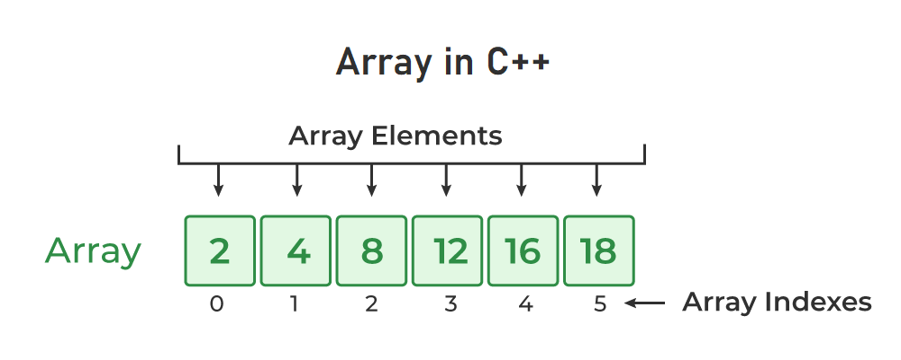

Properties of Arrays in C++:
- Array Declaration in C++An Array is a collection of data of the same data type, stored at a contiguous memory location.
- Indexing of an array starts from 0. It means the first element is stored at the 0th index, the second at 1st, and so on.
- Elements of an array can be accessed using their indices.
- Once an array is declared its size remains constant throughout the program.
- An array can have multiple dimensions.
- The size of the array in bytes can be determined by the sizeof operator using which we can also find the number of elements in the array.
- We can find the size of the type of elements stored in an array by subtracting adjacent addresses.

Array Declaration in C++
In C++, we can declare an array by simply specifying the data type first and then the name of an array with its size.
data_type array_name[Size_of_array];
Example
int arr[5];
Here,
- int: It is the type of data to be stored in the array. We can also use other data types such as char, float, and double.
- arr: It is the name of the array.
- 5: It is the size of the array which means only 5 elements can be stored in the array.
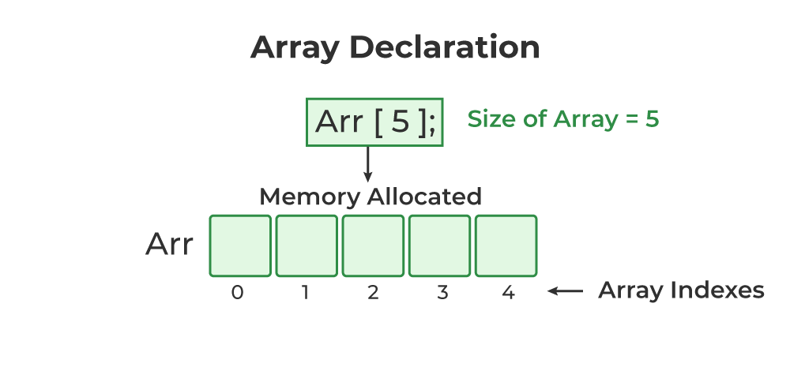

Initialization of Array in C++
In C++, we can initialize an array in many ways but we will discuss some most common ways to initialize an array. We can initialize an array at the time of declaration or after declaration.

1. Initialize Array with Values in C++
We have initialized the array with values. The values enclosed in curly braces ‘{}’ are assigned to the array. Here, 1 is stored in arr[0], 2 in arr[1], and so on. Here the size of the array is 5.
int arr[5] = {1, 2, 3, 4, 5};

2. Initialize Array with Values
We have initialized the array with values but we have not declared the length of the array, therefore, the length of an array is equal to the number of elements inside curly braces.
int arr[] = {1, 2, 3, 4, 5};

3. Initialize Array after Declaration (Using Loops)
We have initialized the array using a loop after declaring the array. This method is generally used when we want to take input from the user or we cant to assign elements one by one to each index of the array. We can modify the loop conditions or change the initialization values according to requirements.
for (int i = 0; i < N; i++) {
arr[i] = value;
}

4. Initialize an array partially in C++
Here, we have declared an array ‘partialArray’ with size ‘5’ and with values ‘1’ and ‘2’ only. So, these values are stored at the first two indices, and at the rest of the indices ‘0’ is storeint partialArray[5] = {1, 2};

5. Initialize the array with zero in C++
We can initialize the array with all elements as ‘0’ by specifying ‘0’ inside the curly braces. This will happen in case of zero only if we try to initialize the array with a different value say ‘2’ using this method then ‘2’ is stored at the 0th index only.
int zero_array[5] = {0};

Accessing an Element of an Array in C++
Elements of an array can be accessed by specifying the name of the array, then the index of the element enclosed in the array subscript operator []. For example, arr[i].

Example 1: The C++ Program to Illustrate How to Access Array Elements
// C++ Program to Illustrate How to Access Array Elements
#include<iostream>
using namespace std;

int main()
{

int arr[3];

// Inserting elements in an array
arr[0]=10;
arr[1]=20;
arr[2]=30;

// Accessing and printing elements of the array
cout<<"arr[0]: "<<arr[0]<<endl;
cout<<"arr[1]: "<<arr[1]<<endl;
cout<<"arr[2]: "<<arr[2]<<endl;

return0;
}
Output
arr[0]: 10
arr[1]: 20
arr[2]: 30

Update Array Element
To update an element in an array, we can use the index which we want to update enclosed within the array subscript operator and assign the new value.
arr[i] = new_value;

One Dimensional Arrays in C++

One-dimensional arrays are like a row of boxes where you can store things where each box can hold one item, such as a number or a word. For example, in an array of numbers, the first box might hold 5, the second 10, and so on. You can easily find or change what's in each box by referring to its position, called an index. Arrays are handy because they let you store lots of related data in one place and access it quickly.
The one dimensional array can be declared as shown below:

Syntax of 1D Array in C++
The one dimensional array can be declared as shown below:
element_type array_name [size]

Properties of 1D Array in C++:
One-dimensional arrays are organized as a sequence of contiguous memory locations, each capable of holding a single data element of the same type

How to Use 1d Array in C++
Usage of one-dimensional arrays in C++ involves declaring the array, initializing it with values (optional), accessing and modifying elements, and performing various operations on the array.

Declaring an Array
To declare an array in C++, you specify the data type of the elements followed by the array name and the size of the array in square brackets. For example, to declare an array of integers with five elements:
int arr[5];
This creates an array named arr capable of holding five integers.

Initializing the Array
You can optionally initialize the array with values at the time of declaration or later using a loop or by assigning values individually. For example:
int arr[5] = {10, 20, 30, 40, 50}; // Initializing with values
This initializes the array arr with five integers: 10, 20, 30, 40, and 50.

Accessing and Modifying Elements
Elements in the array are accessed using indices, starting from 0 for the first element. You can access and modify elements using square brackets []. For example:
int value = arr[2]; // Accessing the element at index 2 (30)
arr[3] = 60; // Modifying the element at index 3 to 60

Performing Basic Operations
You can perform various operations on arrays, such as searching for an element, sorting the elements, or calculating the sum of all elements. These operations typically involve iterating through the array using loops and applying the necessary logic. For example, to find the sum of all elements in the array:
int sum = 0;
for (int i = 0; i < 5; i++) {
sum += arr[i];
}
This loop iterates through each element of the array and adds it to the sum variable.

Complexity Analysis of Basic Array Operations
Several basic operations can be performed on one-dimensional arrays in C++, each with its associated time and space complexity:

Accessing an Element by Index
Time Complexity: O(1). Since arrays provide constant-time access to elements based on their indices, accessing an element by index takes constant time regardless of the size of the array.

Space Complexity: O(1). This operation requires no additional space beyond the memory used by the array itself.

Modifying an Element by Index
Time Complexity: O(1). Similar to accessing an element, modifying an element by index takes constant time regardless of the size of the array.

Space Complexity: O(1). No additional space is required beyond the memory used by the array.

Example of One Dimensional Array in C++
#include<iostream>
usingnamespacestd;

intmain(){
// Declaration and initialization of an array
intarr[5]={10,20,30,40,50};

// Accessing elements of the array
cout<<"Element at index 2: "<<arr[2]<<endl;

// Modifying elements of the array
arr[3]=60;
cout<<"Modified element at index 3: "<<arr[3]<<endl;

// Calculating the sum of all elements
intsum=0;
for(inti=0;i<5;i++){
sum+=arr[i];
}
cout<<"Sum of all elements: "<<sum<<endl;

return0;
}
Output
Element at index 2: 30
Modified element at index 3: 60
Sum of all elements: 170

Applications of One Dimensional Array:
One-dimensional arrays in C++ find wide-ranging applications across various domains due to their simplicity, efficiency, and versatility. Here are some common applications of one-dimensional arrays:
- Data Storage and Retrieval
- Numerical Computations
- Algorithm Design and Implementation
- Input and Output Operations
- Memory Management'.
Two Dimensional Arrays:
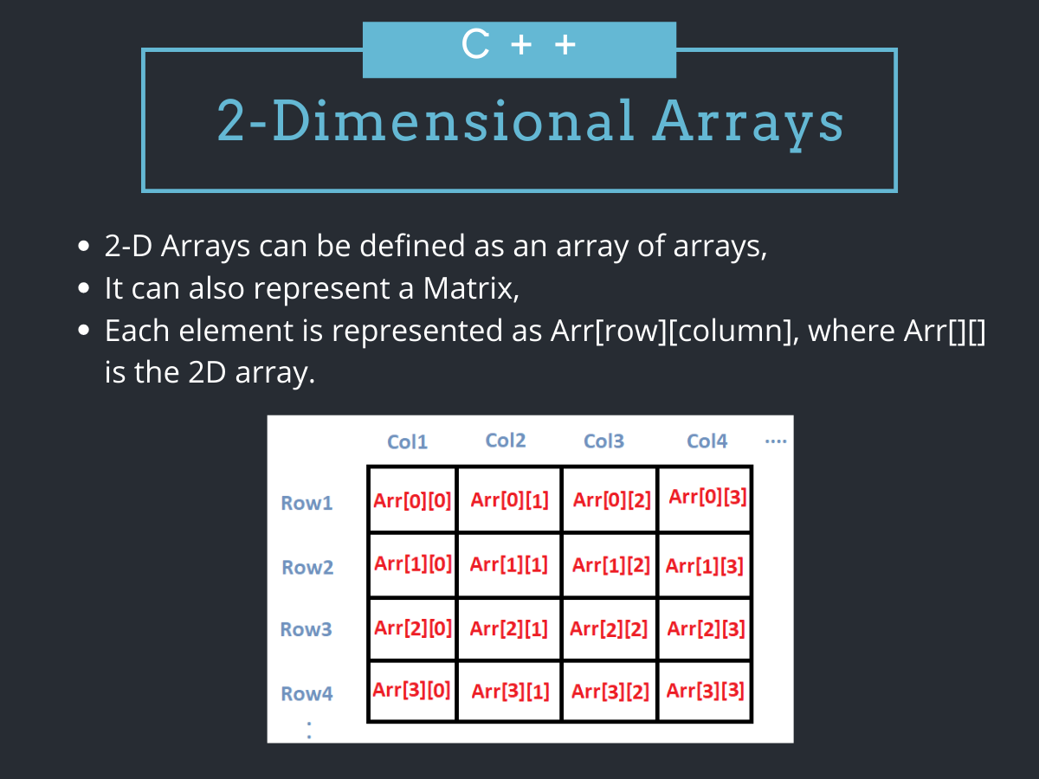

A two-dimensional array in C++ is the simplest form of a multi-dimensional array. It can be visualized as an array of arrays. The image below depicts a two-dimensional array.

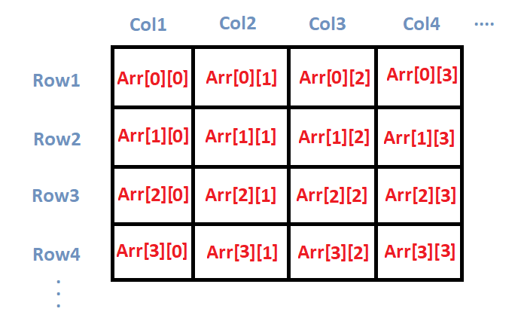

A two-dimensional array is also called a matrix. It can be of any type like integer, character, float, etc. depending on the initialization. In the next section, we are going to discuss how we can initialize 2D arrays.

Initializing a 2D array in C++:

So, how do we initialize a two-dimensional array in C++? As simple as this:

int arr[4][2]={
{1234,56},
{1212,33},
{1434,80},
{1312,78}
};
So, as you can see, we initialize a 2D array arr, with 4 rows and 2 columns as an array of arrays. Each element of the array is yet again an array of integers.
We can also initialize a 2D array in the following way.
int arr[4][2]={1234,56,1212,33,1434,80,1312,78};

Printing a 2D Array in C++
The code below shows us how we can do that.
#include<iostream>
usingnamespace std;
main( )
{
int arr[4][2] = {
{ 10, 11 },
{ 20, 21 },
{ 30, 31 },
{ 40, 41 }
} ;

int i,j;

cout<<"Printing a 2D Array:\n";
for(i=0;i<4;i++)
{
for(j=0;j<2;j++)
{
cout<<"\t"<<arr[i][j];
}
cout<<endl;
}
}
OUTPUT
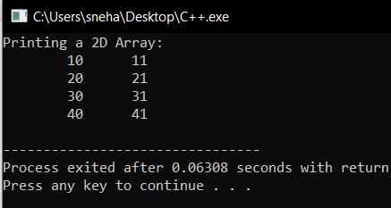

- We firstly initialize a 2D array, arr[4][2] with certain values,
- After that, we try to print the respective array using two for loops,
- the outer for loop iterates over the rows, while the inner one iterates over the columns of the 2D array,
- So, for each iteration of the outer loop, i increases and takes us to the next 1D array. Also, the inner loop traverses over the whole 1D array at a time,
- And accordingly, we print the individual element arr[ i ][ j ].

Matrix Addition using Two Dimensional Arrays in C++

#include<iostream>
usingnamespace std;
main()
{
int m1[5][5], m2[5][5], m3[5][5];
int i, j, r, c;

cout<<"Enter the no.of rows of the matrices to be added(max 5):";
cin>>r;
cout<<"Enter the no.of columns of the matrices to be added(max 5):";
cin>>c;

cout<<"\n1st Matrix Input:\n";
for(i=0;i<r;i++)
{
for(j=0;j<c;j++)
{
cout<<"\nmatrix1["<<i<<"]["<<j<<"]= ";
cin>>m1[i][j];
}
}

cout<<"\n2nd Matrix Input:\n";
for(i=0;i<r;i++)
{
for(j=0;j<c;j++)
{
cout<<"\nmatrix2["<<i<<"]["<<j<<"]= ";
cin>>m2[i][j];
}
}

cout<<"\nAdding Matrices...\n";

for(i=0;i<r;i++)
{
for(j=0;j<c;j++)
{
m3[i][j]=m1[i][j]+m2[i][j];
}
}

cout<<"\nThe resultant Matrix is:\n";

for(i=0;i<r;i++)
{
for(j=0;j<c;j++)
{
cout<<"\t"<<m3[i][j];
}
cout<<endl;
}

}

Output:
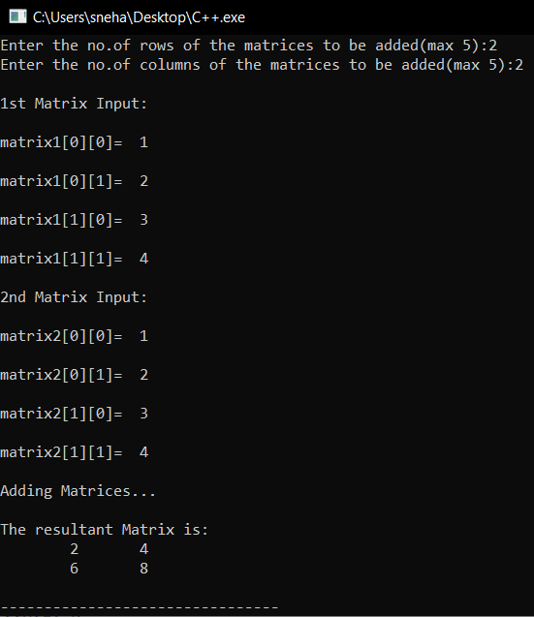
Here,
- We take two matrices m1 and m2 with a maximum of 5 rows and 5 columns. And another matrix m3 in which we are going to store the result,
- As user inputs, we took the number of rows and columns for both the matrices. Since we are performing matrix addition, the number of rows and columns should be the same for both the matrices,
- After that, we take both the matrices as user inputs, again using nested for loops,
- At this point, we have both the matrices m1 and m2,
- then we traverse through the m3 matrix, using two for loops and update the respective elements m3[ i ][ j ] by the value of m1[i][j]+m2[i][j]. In this way, by the end of the outer for loop, we get our desired matrix,
- At last, we print out the resultant matrix m3.

Passing 2-D Array to a Function
To pass a 2D array to any function and access the corresponding elements. In the code below, we pass the array a, to two functions show() and print() which prints out the passed 2D array.

#include<iostream>
usingnamespace std;

voidshow(int(*q)[4],int row,int col)
{
int i, j ;
for(i=0;i<row;i++)
{
for(j=0;j<col;j++)
cout<<"\t"<<*(*(q + i)+j);
cout<<"\n";
}
cout<<"\n";
}

voidprint(int q[][4],int row,int col)
{
int i, j;
for(i=0;i<row;i++)
{
for(j=0;j<col;j++)
cout<<"\t"<<q[i][j];
cout<<"\n";
}
cout<<"\n";
}

intmain()
{
int a[3][4]={10,11,12,13,14,15,16,17,18,19,20,21};

show(a,3,4);
print(a,3,4);
return0;
}

OUTPUT
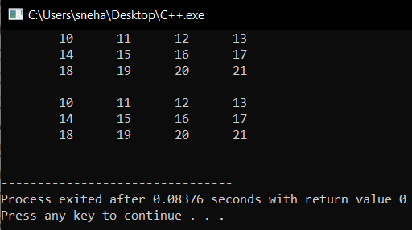
Here,
- In the show( ) function we have defined q to be a pointer to an array of 4 integers through the declaration int (*q)[4],
- q holds the base address of the zeroth 1-D array
- This address is then assigned to q, an int pointer, and then using this pointer all elements of the zeroth 1D array are accessed.
- Next time through the loop when i takes a value 1, the expression q+i fetches the address of the first 1-D array. This is because q is a pointer to the zeroth 1-D array and adding 1 to it would give us the address of the next 1-D array. This address is once again assigned to q and using it all elements of the next 1-D array are accessed
- In the second function print(), the declaration of q looks like this: int q[][4] ,
- This is same as int (*q )[4], where q is a pointer to an array of 4 integers. The only advantage is that we can now use the more familiar expression q[i][j] to access array elements. We could have used the same expression in show() as well but for better understanding of the use of pointers, we use pointers to access each element.

Row Major Order and Column Major Order:
Row major ordering assigns successive elements, moving across the rows and then down the next row, to successive memory locations. In simple language, the elements of an array are stored in a Row-Wise fashion.
To find the address of the element using row-major order uses the following formula:
Address of A[I][J] = B + W * ((I – LR) * N + (J – LC))
= Row Subset of an element whose address to be found,
J = Column Subset of an element whose address to be found,
B = Base address,
W = Storage size of one element store in an array(in byte),
LR = Lower Limit of row/start row index of the matrix(If not given assume it as zero),
LC = Lower Limit of column/start column index of the matrix(If not given assume it as zero),
N = Number of column given in the matrix.

How to find address using Row Major Order?
Given an array, arr[1………10][1………15] with base value 100 and the size of each element is 1 Byte in memory. Find the address of arr[8][6] with the help of row-major order.
Solution:
Given:
Base address B = 100
Storage size of one element store in any array W = 1 Bytes
Row Subset of an element whose address to be found I = 8
Column Subset of an element whose address to be found J = 6
Lower Limit of row/start row index of matrix LR = 1
Lower Limit of column/start column index of matrix = 1
Number of column given in the matrix N = Upper Bound – Lower Bound + 1
= 15 – 1 + 1
= 15
Formula:
Address of A[I][J] = B + W * ((I – LR) * N + (J – LC))
Solution:
Address of A[8][6] = 100 + 1 * ((8 – 1) * 15 + (6 – 1))
= 100 + 1 * ((7) * 15 + (5))
= 100 + 1 * (110)
Address of A[I][J] = 210

Column Major Order
If elements of an array are stored in a column-major fashion means moving across the column and then to the next column then it’s in column-major order. To find the address of the element using column-major order use the following formula:
Address of A[I][J] = B + W * ((J – LC) * M + (I – LR))
I = Row Subset of an element whose address to be found,
J = Column Subset of an element whose address to be found,
B = Base address,
W = Storage size of one element store in any array(in byte),
LR = Lower Limit of row/start row index of matrix(If not given assume it as zero),
LC = Lower Limit of column/start column index of matrix(If not given assume it as zero),
M = Number of rows given in the matrix.

How to find address using Column Major Order?
Given an array arr[1………10][1………15] with a base value of 100 and the size of each element is 1 Byte in memory find the address of arr[8][6] with the help of column-major order.
Solution:
Given:
Base address B = 100
Storage size of one element store in any array W = 1 Bytes
Row Subset of an element whose address to be found I = 8
Column Subset of an element whose address to be found J = 6
Lower Limit of row/start row index of matrix LR = 1
Lower Limit of column/start column index of matrix = 1
Number of Rows given in the matrix M = Upper Bound – Lower Bound + 1
= 10 – 1 + 1
= 10

Formula: used
Address of A[I][J] = B + W * ((J – LC) * M + (I – LR))
Address of A[8][6] = 100 + 1 * ((6 – 1) * 10 + (8 – 1))
= 100 + 1 * ((5) * 10 + (7))
= 100 + 1 * (57)
Address of A[I][J] = 157

Row Major Order vs Column Major Order
Aspect | Row Major Order | Column Major Order
Memory Organization | Elements are stored row by row in contiguous locations. | Elements are stored column by column in contiguous locations.
Memory Layout Example | For a 2D array A[m][n]: [A[0][0], A[0][1], ..., A[m-1][n-1]] | For the same array: [A[0][0], A[1][0], ..., A[m-1][n-1]]
Traversal Direction | Moves through the entire row before progressing to the next row. | Moves through the entire column before progressing to the next column.

Access Efficiency | Efficient for row-wise access, less efficient for column-wise access. | Efficient for column-wise access, less efficient for row-wise access.
Common Use Cases | Commonly used in languages like C and C++. | Commonly used in languages like Fortran.
Applications | Suitable for row-wise operations, e.g., image processing. | Suitable for column-wise operations, e.g., matrix multiplication.

DYNAMIC ARRAY IN C++
A dynamic array is an array whose size can change during runtime. Unlike static arrays, dynamic arrays can grow automatically when more elements are added.
A simple dynamic array can be constructed by allocating an array of fixed-size, typically larger than the number of elements immediately required. The elements of the dynamic array are stored contiguously at the start of the underlying array, and the remaining positions towards the end of the underlying array are reserved, or unused.
Elements can be added at the end of a dynamic array in constant time by using the reserved space until this space is completely consumed. When all space is consumed, and an additional element is to be added, the underlying fixed-sized array needs to be increased in size. In this case a larger array is allocated and all existing elements are copied into the new array before inserting the new element.
This resizing operation is expensive because it requires allocating new memory and copying all existing elements.
Resizing Strategy
In practice, dynamic arrays usually increase capacity by a growth factor (commonly 2×).
Capacity: 4 → 8 → 16 → 32
Example :
#include <iostream>
#include <vector>
using namespace std;
int main() {
vector<int> arr;
arr.push_back(10);
arr.push_back(20);
arr.push_back(30);
cout << "Size: " << arr.size() << endl;
cout << "Capacity: " << arr.capacity() << endl;
return 0;
}
size() → number of elements
capacity() → allocated storage
When push_back() is called and the vector becomes full, C++ automatically increases the capacity (usually doubling it) and copies the elements to a new larger memory block.
Explanation :
Initial capacity = 4
[10][20][30][ _ ]
Add 40
[10][20][30][40]
Add 50 → Resize
New capacity = 8
[10][20][30][40][50][ _ ][ _ ][ _ ]
Dynamic Array Using new Operator (Runtime Allocation)
In C++, memory can be allocated during program execution using the new operator. This allows the array size to be decided at runtime instead of compile time.
Example
#include <iostream>
using namespace std;
int main() {
int n;
cout << "Enter size: ";
cin >> n;
int* arr = new int[n]; // dynamic array
for(int i = 0; i < n; i++)
arr[i] = i + 1;
for(int i = 0; i < n; i++)
cout << arr[i] << " ";
delete[] arr; // free memory
}

Explanation
- new int[n] allocates memory dynamically.
- The array size is decided during execution.
- delete[] releases the allocated memory.
Limitation
The size cannot automatically increase. If you need a larger array, you must manually create a new one and copy elements.
Dynamic Array Using malloc() and realloc()
C-style memory functions from <cstdlib> can also be used.
#include <iostream>
#include <cstdlib>
using namespace std;
int main() {
int* arr = (int*) malloc(3 * sizeof(int));
arr[0] = 10;
arr[1] = 20;
arr[2] = 30;
arr = (int*) realloc(arr, 5 * sizeof(int));
arr[3] = 40;
arr[4] = 50;
for(int i = 0; i < 5; i++)
cout << arr[i] << " ";
free(arr);
}
Explanation
- malloc() allocates memory.
- realloc() resizes the memory block.
- free() releases memory.
Limitation
- Does not call constructors.
- Not recommended in modern C++, but useful for understanding memory allocation.
Manual Dynamic Array Implementation :
This is the actual data structure concept behind dynamic arrays and vectors.
A dynamic array keeps track of:
- size → number of elements stored
- capacity → total allocated memory
When size == capacity, the array resizes (usually doubles).
#include <iostream>
using namespace std;
class DynamicArray {
private:
int* arr;
int size;
int capacity;
public:
DynamicArray() {
capacity = 2;
size = 0;
arr = new int[capacity];
}
void insert(int value) {
if(size == capacity) {
capacity = capacity * 2;
int* newArr = new int[capacity];
for(int i = 0; i < size; i++)
newArr[i] = arr[i];

delete[] arr;
arr = newArr;
}
arr[size] = value;
size++;
}
void display() {
for(int i = 0; i < size; i++)
cout << arr[i] << " ";
}
};
int main() {
DynamicArray d;
d.insert(10);
d.insert(20);
d.insert(30);
d.insert(40);
d.display();
}
How It Works
Initial:
capacity = 2
size = 0
After inserting elements:
[10][20]
size = 2 capacity = 2
Next insertion → resize
capacity = 4
[10][20][30][ ]

Polynomial is a heavily templated C++ class for polynomials. It provides functionality for polynomial algebra (addition, subtraction, and multiplication) as well as root-finding using either the numerically-accurate companion matrix method or the much faster Sturm sequences method.

POLYNOMIAL IN C++
A polynomial is a mathematical expression consisting of variables, coefficients, and exponents combined using arithmetic operations.
General form:
P(x) = a_n x^n + a_(n-1) x^(n-1) + ... + a_2 x^2 + a_1 x + a_0
Where:
a_n, a_(n-1), ..., a_0 → coefficients
x → variable
n → degree of the polynomial
Example:
P(x) = 4x^3 + 3x^2 + 7x + 2
Polynomial Representation in C++:
In C++, polynomials are usually implemented using a class where coefficients are stored in an array or vector and the index represents the exponent.
Example representation:
Polynomial: 4x^3 + 3x^2 + 7x + 2
Exponent (index): 3 2 1 0
Coefficient: 4 3 7 2
Polynomial Class in C++:
A Polynomial class encapsulates polynomial data and operations.
Example:
#include <iostream>
#include <vector>
using namespace std;
class Polynomial {
private:
vector<int> coef;
public:
Polynomial(int degree) {
coef.resize(degree + 1);
}
void setCoefficient(int exp, int value) {
coef[exp] = value;
}
void display() {
for(int i = coef.size()-1; i >= 0; i--) {
if(coef[i] != 0)
cout << coef[i] << "x^" << i << " + ";
}
cout << endl;
}
};
Polynomial Algebra Operations
A polynomial class usually supports addition, subtraction, and multiplication.
Polynomial Addition
P(x) = 3x^2 + 4x + 5
Q(x) = 2x^2 + 6x + 1
Result:
R(x) = 5x^2 + 10x + 6
Code:
for(i=0;i<=deg;i++)
result[i] = p[i] + q[i];
Polynomial Subtraction
R(x) = P(x) - Q(x)
Example:
(3x^2 + 4x + 5) - (2x^2 + x + 1)= x^2 + 3x + 4
Polynomial Multiplication
Example:
(2x + 3)(x + 4)
Result:
2x^2 + 11x + 12
Code:
for(i=0;i<=deg1;i++)
{
for(j=0;j<=deg2;j++)
{
result[i+j] += p[i] * q[j]; }}
Polynomial Root Finding
Roots are values of x for which:
P(x) = 0
Example:
x^2 - 5x + 6 = 0
Roots:
x = 2, 3
Companion Matrix Method
This method converts the polynomial root-finding problem into a matrix eigenvalue problem.
Steps:
1. Convert polynomial into a companion matrix.
2. Compute eigenvalues of the matrix.
3. Eigenvalues correspond to polynomial roots.
Advantages:
- Numerically accurate
- Used in scientific computing
Disadvantage:
- Computationally expensive for large polynomials
Sturm Sequences Method
Sturm sequence method determines the number of real roots within a given interval.
Steps:
1. Construct a Sturm sequence of polynomials.
2. Evaluate the sequence at two values.
3. Count sign changes.
4. Difference gives the number of real roots.
Advantages:
- Faster than the companion matrix method
- Efficient for real root isolation
Template-Based Polynomial Class
Templates allow the polynomial class to work with different numeric types.
Example:
template<typename T>
class Polynomial
{
private:
vector<T> coef;
public:
Polynomial(int degree)
{
coef.resize(degree + 1);
}
};
This allows usage such as:
Polynomial<int>
Polynomial<float>
Polynomial<double>
Applications of Polynomial Classes
Polynomial classes are used in:
  - Scientific computing
  - Signal processing
  - Control systems
  - Numerical analysis
  - Computer algebra systems
  - Graphics and curve fitting
Conclusion
A Polynomial class in C++ represents polynomials using arrays or vectors and supports operations like addition, subtraction, multiplication, and evaluation. Advanced implementations include root-finding techniques such as the companion matrix method and Sturm sequences.

Sparse Matrix and its representations
A matrix is a two-dimensional data object made of m rows and n columns, therefore having total m x n values. If most of the elements of the matrix have 0 value, then it is called a sparse matrix.
Why to use Sparse Matrix instead of simple matrix ?
- Storage: There are lesser non-zero elements than zeros and thus lesser memory can be used to store only those elements.
- Computing time: Computing time can be saved by logically designing a data structure traversing only non-zero elements..
- Example:

- 0 0 3 0 4
0 0 5 7 0
0 0 0 0 0
0 2 6 0 0

Representing a sparse matrix by a 2D array leads to wastage of lots of memory as zeroes in the matrix are of no use in most of the cases. So, instead of storing zeroes with non-zero elements, we only store non-zero elements. This means storing non-zero elements with triples- (Row, Column, value).

Sparse Matrix Representations can be done in many ways following are two common representations:
1.Array representation
2.Linked list representation

Method 1: Using Arrays:
2D array is used to represent a sparse matrix in which there are three rows named as
Row: Index of row, where non-zero element is located
Column: Index of column, where non-zero element is located
Value: Value of the non zero element located at index – (row,column)
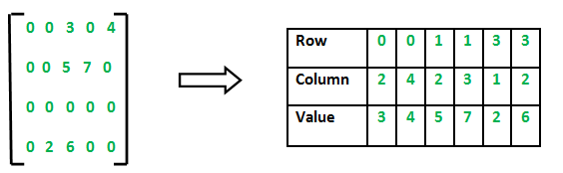
C++ program for Sparse Matrix Representation
// using Array
#include <iostream>
using namespace std;

int main()
{
// Assume 4x5 sparse matrix
int sparseMatrix[4][5] =
{
{0 , 0 , 3 , 0 , 4 },
{0 , 0 , 5 , 7 , 0 },
{0 , 0 , 0 , 0 , 0 },
{0 , 2 , 6 , 0 , 0 }
};

int size = 0;
for (int i = 0; i < 4; i++)
for (int j = 0; j < 5; j++)
if (sparseMatrix[i][j] != 0)
size++;
int compactMatrix[3][size];

// Making of new matrix
int k = 0;
for (int i = 0; i < 4; i++)
for (int j = 0; j < 5; j++)
if (sparseMatrix[i][j] != 0)
{
compactMatrix[0][k] = i;
compactMatrix[1][k] = j;
compactMatrix[2][k] = sparseMatrix[i][j];
k++;
}

for (int i=0; i<3; i++)
{
for (int j=0; j<size; j++)
cout <<" "<< compactMatrix[i][j];

cout <<"\n";
}
return 0;
}
Output
0 0 1 1 3 3
2 4 2 3 1 2
3 4 5 7 2 6
Time Complexity: O(NM), where N is the number of rows in the sparse matrix, and M is the number of columns in the sparse matrix.
Auxiliary Space: O(NM), where N is the number of rows in the sparse matrix, and M is the number of columns in the sparse matrix.

Method 2: Using Linked Lists
In linked list, each node has four fields. These four fields are defined as:
- Row: Index of row, where non-zero element is located
- Column: Index of column, where non-zero element is located
- Value: Value of the non zero element located at index – (row,column)
- Next node: Address of the next node

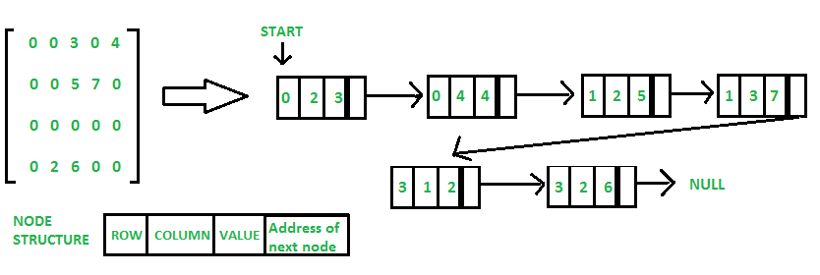
#include <iostream>
using namespace std;
class Node
{
public:
int row;
int col;
int val;
Node *next;
Node(int r,int c, int v)
{
// newnode=(struct *Node)malloc(sizeof(struct Node));
row=r;
col=c;
val=v;
next=NULL;
}
};
class SparseList
{
private:
Node *head;
public:
SparseList()
{
head=NULL;
}
void createSparse(int row, int col,int val)
{
Node *newnode=new Node(row,col,val);
if(head==NULL)
head=newnode;
else
{
Node *temp=head;
while(temp->next!=NULL)
{
temp=temp->next;
}
temp->next=newnode;
}
}
void showSparse()
{
Node *temp=head;
while(temp!=NULL)
{
cout <<temp->row<<" "<<temp->col<< " "<<temp->val;
cout<<endl;
temp=temp->next;
}

}
};
int main() {

SparseList sp;
int m,n;
cout << "enter dimensions of matrix"<<endl;
cin>>m>>n;
int A[m][n];
cout << "enter matrix"<<endl;
for(int i = 0; i < m; i++)
{
for(int j = 0; j < n; j++)
{
cin>>A[i][j];
}
}
for(int i = 0; i < m; i++)
{
for(int j = 0; j < n; j++)
{
if(A[i][j]!=0)
sp.createSparse(i,j,A[i][j]);

}
}
cout << "Sparse matrix using linked list"<<endl;
sp.showSparse();
return 0;
}
Output

enter dimensions of matrix

4

4

enter matrix

0 0 3 0

0 0 0 4

0 0 0 0

0 6 8 0

Sparse matrix using linked list

0 2 3

1 3 4

3 1 6

3 2 8

Time Complexity: O(N*M), where N is the number of rows in the sparse matrix, and M is the number of columns in the sparse matrix.
Auxiliary Space: O(K), where K is the number of non-zero elements in the array.

Dynamic Array vs Array

Normal Array (Static Array)

Example:

int arr[5];

Characteristics:

Size is fixed at compile time

Memory is allocated in stack

Size cannot change

Automatically destroyed when function ends

Example Program:

#include <iostream>

using namespace std;

int main() {

int arr[5] = {1,2,3,4,5};

for(int i=0;i<5;i++)

cout << arr[i] << " ";

return 0;

}

Dynamic Array

Example:

int* arr = new int[n];

Characteristics:

Size decided at runtime

Memory allocated in heap

Size depends on user input

Must manually free memory using delete[]

Example Program:

#include <iostream>

using namespace std;

int main() {

int n;

cout << "Enter size: ";

cin >> n;

int* arr = new int[n]; // dynamic allocation

for(int i=0;i<n;i++)

cin >> arr[i];

for(int i=0;i<n;i++)

cout << arr[i] << " ";

delete[] arr; // free memory

return 0;

}

Major Differences

Feature Static Array Dynamic Array

Size decided Compile time Runtime

Memory location Stack Heap

Size changeable? No Can recreate

Memory release Automatic Manual (delete[])

Flexibility Low High

Linear Data Structure
A data structure is a way of organizing and storing data so that it can be accessed and modified efficiently.
Data structures are mainly classified into:
1.Linear Data Structures
2.Non-Linear Data Structures
Linear Data Structures
In a linear data structure, elements are arranged in a sequential order, meaning each element has a unique predecessor and successor (except the first and last elements).
Example:
10 → 20 → 30 → 40 → 50
Characteristics:
- Elements are stored sequentially
- Traversal occurs in a single direction
- Easy to implement and understand
Examples of linear data structures:
- Arrays
- Linked Lists
- Stacks
- Queues
Linear List ADT:
A Linear List Abstract Data Type (ADT) is a logical representation of a collection of elements arranged in sequential order.
It specifies:
- what operations can be performed.
- without specifying how they are implemented.
The actual implementation can be done using: Arrays and Linked Lists

Example of Linear List
L = {10, 20, 30, 40}
Positions:
Index | Element
0 | 10
1 | 20
2 | 30
3 | 40
Operations on Linear List ADT
Common operations include:
Operation | Description
Insert | Add element at a position
Delete | Remove element
Search | Find element
Traverse | Visit all elements
Update | Modify element
Size | Number of elements
Array Representation of Linear List
In this representation, the elements of the linear list are stored in contiguous memory locations using an array.
Example:
Index: 0 1 2 3
Array: [10][20][30][40]
Characteristics:
- Elements stored sequentially in memory
- Access using index
- Fast element access
C++ Example (Array Representation)
#include <iostream>
using namespace std;
int main()
{
int arr[5] = {10, 20, 30, 40, 50};

cout << "Elements of Linear List (Array): ";

for(int i = 0; i < 5; i++)
{
cout << arr[i] << " ";
}
return 0;
}
Output
Elements of Linear List (Array): 10 20 30 40 50
Advantages of Array Representation
- Simple to implement
- Fast random access
- Efficient memory usage for fixed size
Disadvantages of Array Representation
- Fixed size
- Insertion and deletion are costly
- Memory wastage if array size is large
Linked List Representation of Linear List
A Linked List is a collection of nodes where each node contains:
- Data
- Pointer to the next node
Unlike arrays, elements are not stored in contiguous memory.
Example:
[10 | next] → [20 | next] → [30 | next] → [40 | next] → NULL
Structure of Node in C++
struct Node
{
int data;
Node* next;
};
C++ Example (Linked List Representation)
#include <iostream>
using namespace std;
struct Node
{
int data;
Node* next;
};
int main()
{
Node* head = new Node();
Node* second = new Node();
Node* third = new Node();

head->data = 10;
head->next = second;

second->data = 20;
second->next = third;

third->data = 30;
third->next = NULL;

Node* temp = head;

while(temp != NULL)
{
cout << temp->data << " ";
temp = temp->next;
}

return 0;
}
Output
10 20 30
Advantages of Linked List
Dynamic size
Efficient insertion and deletion
No memory wastage
Disadvantages of Linked List
Extra memory for pointers
Sequential access only
Implementation is more complex
Comparison: Array vs Linked List Representation
Feature | Array | Linked List
Memory | Contiguous | Non-contiguous
Size | Fixed | Dynamic
Access | Random access | Sequential access
Insertion | Costly | Easy
Deletion | Costly | Easy

A Linear List ADT represents a sequence of elements where operations like insertion, deletion, and traversal can be performed. It can be implemented using arrays or linked lists. Arrays provide fast access but have fixed size, while linked lists allow dynamic memory allocation but require additional pointer storage.

Abstract Data Type

In computer science, an abstract data type (ADT) is a mathematical model for data types where a data type is defined by its behavior (semantics) from the point of view of a user of the data, specifically in terms of possible values, possible operations on data of this type, and the behavior of these operations. When a class is used as a type, it is an abstract type that refers to a hidden representation. In this model an ADT is typically implemented as a class, and each instance of the ADT is usually an object of that class. In ADT all the implementation details are hidden
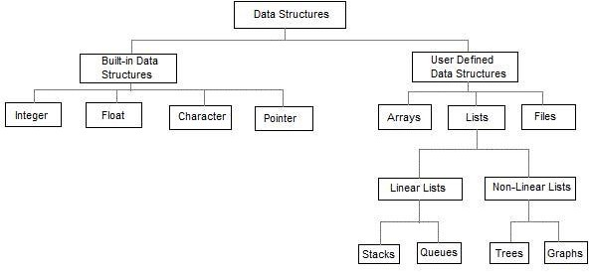
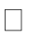

Linear data structures are the data structures in which data is arranged in a list or in a sequence. Nonlinear data structures are the data structures in which data may be arranged in a hierarchic al manner.

LISTADT
List is basically the collection of elements arranged in a sequential manner. In memory we can store the list in two ways: one way is we can store the elements in sequential memory locations. That means we can store the list in arrays. The other way is we can use pointers or links to associate elements sequentially. This is known as linked list.

LINKEDLISTS: The linked list is very different type of collection from an array. Using such lists, we can store collections of information limited only by the total amount of memory that the OS will allow us to use. Further more, there is no need to specify our needs in advance. The linked list is very flexible dynamic data structure : items may be added to it or deleted from it at will. A programmer need not worry about how many items a program will have to accommodate in advance. This allows us to write robust programs which require much less maintenance.

The linked allocation has the following drawbacks:
- No direct access to a particular element.
- Additional memory required for pointers.

Linked list are of 3 types:

- SinglyLinkedList
- DoublyLinkedList
- CircularlyLinkedList

SINGLYLINKEDLIST

A singly linked list, or simply a linked list, is a linear collection of data items. The linearorderisgivenbymeansofPOINTERS.Thesetypesoflistsareoftenreferredto as linear linked list.
  - Eachiteminthelistiscalledanode.
  - Eachnodeof thelist has two fields:
- Information-containstheitembeingstoredinthelist.
- Nextaddress-contains theaddress ofthenext item in thelist.

*ThelastnodeinthelistcontainsNULLpointertoindicatethatitistheend of the list. Conceptual view of Singly Linked List

Operations on Singlylinked list:
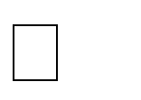Insertion of a node
Deletionsofanode
Traversing the list

Structureofanode: Method -1:
structnode
link
Data
{
int data;
structnode *link;
};

Method-2:
classnode
{
public:
int data;
node*link;
};
Insertions:To place anelements inthe listthereare3cases :
- At the beginning
- End ofthe list
- Atagiven position

case1:Insertatthebeginning
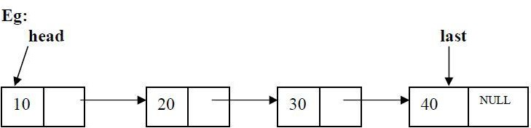
temp

headisthepointervariablewhichcontainsaddressofthefirstnodeand tempcontains address of new node to be inserted then sample code is
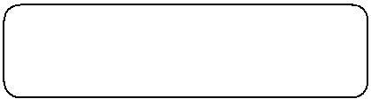
temp->link=head; head=temp;
After insertion:
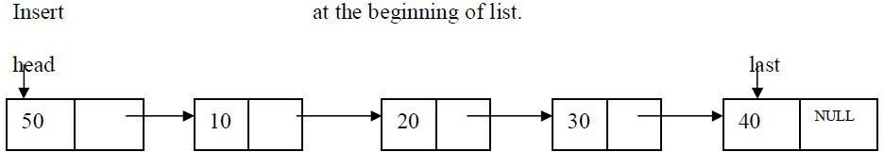
code for insert front:-

template<classT>
void list<T>::insert_front()
{
struct node <T>*t,*temp; cout<<"Enterdataintonode:"; cin>>item; temp=create_node(item); if(head==NULL)
head=temp;
else
{temp->link=head;
head=temp;
}
}

case2:Insertingend ofthelist
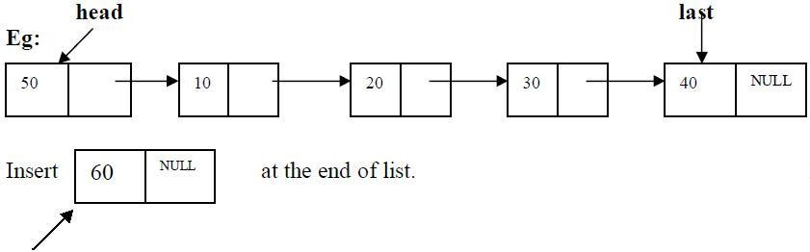
temp

headisthepointervariablewhichcontainsaddressofthefirstnodeand tempcontains address of new node to be inserted then sample code is
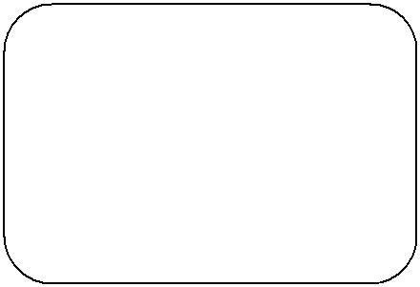
t=head;
while(t->link!=NULL)
{
t=t->link;
}
t->link=temp;
Afterinsertionthe linked list is
codeforinsert atEnd:-
template<classT>
void list<T>::insert_end()
{
structnode<T>*t,*temp; int n;
cout<<"Enterdataintonode:"; cin>>n;
temp=create_node(n); if(head==NULL)
head=temp;
else
{t=head;while(t-
>link!=NULL)
t=t->link; t->link=temp;
}
}

case3: Insert at a position

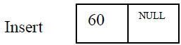

insert node at position 3
headisthepointervariablewhichcontainsaddressofthefirstnodeandtempcontains address of new node to be inserted then sample code is

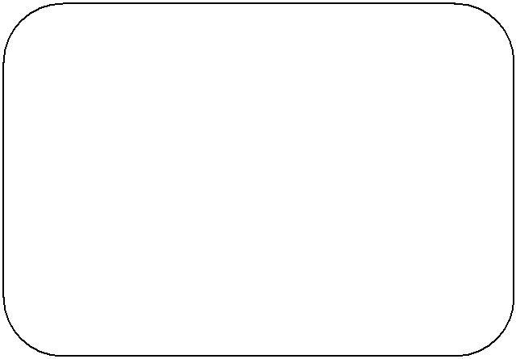
c=1;
while(c<pos)
{
prev=cur; cur=cur->link; c++;
}
prev->link=temp; temp->link=cur;
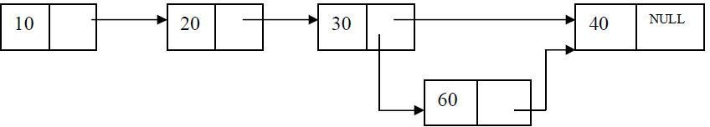
Code for inserting a node at a given position:-
template<classT>
voidlist<T>::Insert_at_pos(intpos)
{structnode<T>*cur,*prev,*temp; int c=1;
cout<<"Enterdataintonode:"; cin>>item temp=create_node(item); if(head==NULL)
head=temp;
else
{
prev=cur=head; if(pos==1)
{

}
else
{
temp->link=head; head=temp;

while(c<pos)
{c++;
prev=cu r;
cur=cur->link;
}
prev->link=temp; temp->link=cur;
}
}
}

Deletions:Removinganelementfromthelist,withoutdestroyingtheintegrityofthelist itself.
Toplaceanelementfrom thelist thereare3cases:
- Deleteanodeat beginningof thelist
- Deleteanodeat end of thelist
- Deleteanodeat a givenposition
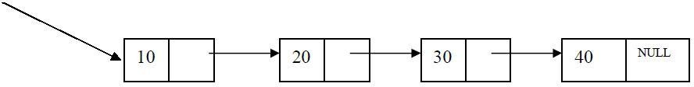
Case1:Deleteanodeatbeginningofthe list head

head isthepointer variablewhichcontainsaddress ofthefirst node

samplecodeis

t=head; head=head->link;
cout<<"node"<<t->data<<"Deletionissucess"; delete(t);

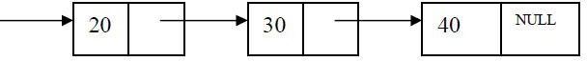
head
Case2.Deleteanodeatendofthelist

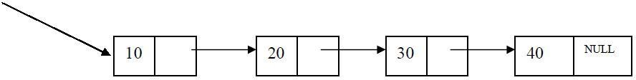
head

Todeletelastnode,findthenodeusingfollowing code
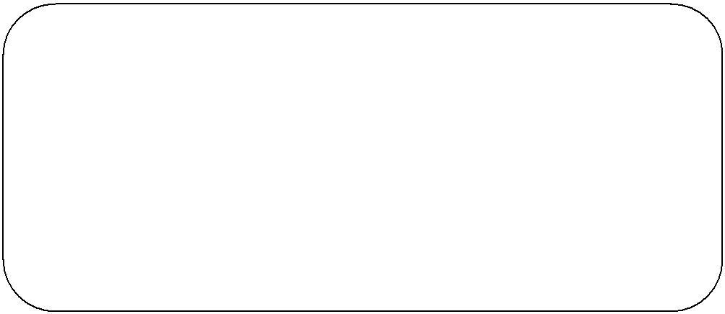
structnode<T>*cur,*prev; cur=prev=head;
while(cur->link!=NULL)
{prev=cur;cur=cur-
>link;
}
prev->link=NULL;
cout<<"node"<<cur->data<<"Deletionissucess"; free(cur);

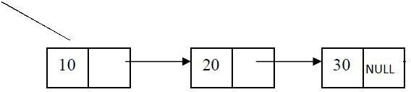
head

Codefordeletinganodeatendof thelist
template<classT>
void list<T>::delete_end()
{
structnode<T>*cur,*prev; cur=prev=head; if(head==NULL)
cout<<"Listis Empty\n";
else
{cur=prev=head;if(head-
>link==NULL)
{

else
cout<<"node"<<cur->data<<"Deletionis sucess"; free(cur);
head=NULL;
}

{while(cur->link!=NULL)
{prev=cur; cur=cur-
>link;
}
prev->link=NULL;
cout<<"node"<<cur->data<<"Deletionissucess"; free(cur);
}
}
}

CASE3.Delete a node at a given position

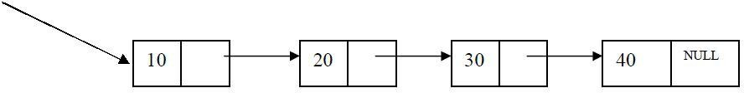
head

Delete node at position 3
headisthepointervariablewhichcontainsaddressofthefirstnode.Nodetobedeletedis nodecontaining value 30. Findingnodeatposition3
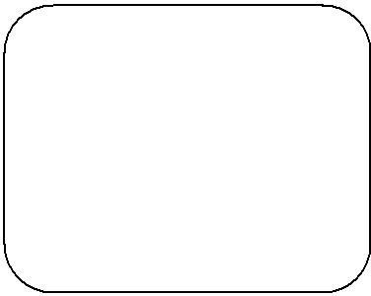
c=1;
while(c<pos)
{c++;
prev=cu r;
cur=cur->link;
}

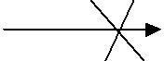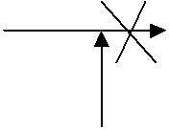prev cur
30
10
20
NULL
40

prev curr
20
30
NULL
40
10

cur is the node to be deleted. Before deleting update links
code to update links
prev->link=cur->link;
cout<<cur->data<<"isdeletedsuccessfully"; delete cur;

Traversingthelist:Assumingwearegiventhepointertotheheadofthelist,howdo we get the end of the list.
template <class T> voidlist<T>::display()
{
structnode<T>*t;
if(head==NULL)
{
cout<<"Listis Empty\n";
}
else
{t=head;
while(t!=NUL L)
{cout<<t->data<<"->"; t=t->link;
}
}

Example for SLL
#include <iostream>
using namespace std;

// Node structure
struct Node {
int data;
Node* next;

Node(int value) {
data = value;
next = nullptr;
}
};

// Singly Linked List Class
class LinkedList {
private:
Node* head;

public:
// Constructor
LinkedList() {
head = nullptr;
}

// Insert at the end
void insert(int value) {
Node* newNode = new Node(value);
if (!head) {
head = newNode;
return;
}
Node* temp = head;
while (temp->next) {
temp = temp->next;
}
temp->next = newNode;
}

// Insert at the beginning
void insertAtBeginning(int value) {
Node* newNode = new Node(value);
newNode->next = head;
head = newNode;
}

// Delete a node by value
void deleteNode(int value) {
if (!head) return;

if (head->data == value) {
Node* temp = head;
head = head->next;
delete temp;
return;
}

Node* temp = head;
while (temp->next && temp->next->data != value) {
temp = temp->next;
}

if (temp->next) {
Node* toDelete = temp->next;
temp->next = temp->next->next;
delete toDelete;
}
}

// Search for a value
bool search(int value) {
Node* temp = head;
while (temp) {
if (temp->data == value) return true;
temp = temp->next;
}
return false;
}

// Display the linked list
void display() {
Node* temp = head;
while (temp) {
cout << temp->data << " -> ";
temp = temp->next;
}
cout << "NULL" << endl;
}

// Destructor to free memory
~LinkedList() {
Node* temp;
while (head) {
temp = head;
head = head->next;
delete temp;
}
}
};

// Main Function
int main() {
LinkedList list;

// Inserting elements at the end
list.insert(10);
list.insert(20);
list.insert(30);
list.insert(40);

// Displaying the list
cout << "Linked List: ";
list.display();

// Insert at the beginning
list.insertAtBeginning(5);
cout << "After inserting 5 at beginning: ";
list.display();

// Searching for an element
int searchVal = 20;
if (list.search(searchVal))
cout << searchVal << " found in the list." << endl;
else
cout << searchVal << " not found in the list." << endl;

// Deleting an element
list.deleteNode(20);
cout << "After deleting 20: ";
list.display();

return 0;
}

DOUBLY LINKED LIST
A singlylinked list has the disadvantage that we can onlytraverse it in one direction. Many applications require searching backwards and forwards through sections of a list. A useful refinement that can be made to the singly linked list is to create a doubly linked list. The distinction made between the two list types is that while singly linked list have pointers going in one direction, doubly linked list have pointer both to the next and to the previous element in the list. The main advantage of a doublylinked list is that, theypermit traversing or searching of the list in both directions.
Inthislinkedlisteachnodecontainsthreefields.
- Oneto storedata
- Remainingareselfreferentialpointerswhichpointstopreviousandnextnodes in the list

prev | data | next

Implementationofnodeusingstructure Method -1:
structnode
{
int data;
struct node *prev; structnode * next;
};

Implementationofnodeusingclass Method -2:
classnode
{
public:
int data; node *prev; node* next;
};

30

20

NUL L
10
NULL

Operations on Doubly linked List: Insertion of a node Deletions of a node Traversing the list

Doubly linked list ADT:
template<classT> class dlist
{

public:
int data;

structdnode<T>*head;
dlist()
{

head=NULL;
}
voiddisplay();
structdnode<T>*create_dnode(intn); void insert_end();
void insert_front(); void delete_end(); void delete_front(); voiddnode_count();
void Insert_at_pos(int pos); voidDelete_at_pos(intpos);
};
Insertions:To place an elements inthe list thereare3 cases
  - At the beginning
  - End of the list
  - At a given position
case1:Insert at the beginning
head is the pointer variable which contains address of the first node and temp contains address of new node to be inserted then sample code.

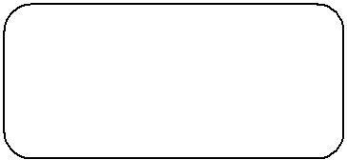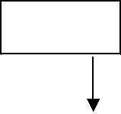
10
40

20
head

30
temp->next=head;
head->prev=temp;
head=temp;

NUL L

Code for insert front:

template<classT>
void DLL<T>::insert_front()
{
struct dnode <T>*t,*temp; cout<<"Enterdataintonode:"; cin>>data; temp=create_dnode(data); if(head==NULL)
head=temp;

else
{

}
}

temp->head=temp;

head->prev=temp;
head=temp;

Codeto inserta nodeatEnd:-

template<classT>

void DLL<T>::insert_end()
{
structdnode<T>*t,*temp; int n;
cout<<"Enterdataintodnode:"; cin>>n;
temp=create_dnode(n); if(head==NULL)
head=temp;
else

{t=head;while(t->next!=NULL)
t=t->next; t->next=temp;
temp->prev=t;

}

}
Code to insert a node at a position:
template<classT>
void dlist<T>::Insert_at_pos(intpos)
{
Structdnode<T>*cr,*pr,*temp; int count=1;
cout<<"Enterdataintodnode:"; cin>>data; temp=create_dnode(data); display();
if(head==NULL)
{//whenlistis empty
head=temp;
}
else
{pr=cr=head;
if(pos==1)
{//insertingatpos=1 temp-
>next=head; head=temp;

}
else
{

while(count<pos)
{count++;
pr=cr;
cr=cr->next;

}
pr->next=temp; temp->prev=pr; temp->next=cr; cr->prev=temp;
}
}
}
Deletions:Removing an element from the list,without destroying the integrity of the list itself.
To place an element from the list there are 3cases :
- Delete a node at beginning of the list
- Delete a node at end of the list
- Delete a node at a given position
Case1:Delete a node at beginning of the list
head

NUL L

30

20
10
NUL L

head is the pointer variable which contains address of the firstnode sample code is
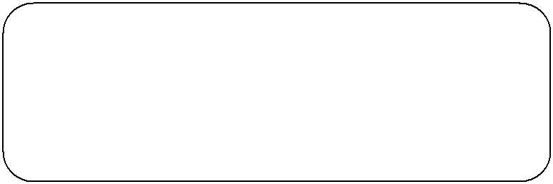
t=head;
head=head-next;
head->prev=NULL;
cout<<"dnode"<<t->data<<"Deletionissucess";
delete(t);

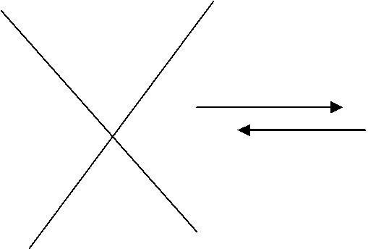
head
10
NULL

NULL

NUL L

30

20

Code for deleting a node at front
template<classT>
voiddlist<T>::delete_front()
{struct dnode<T>*t;
if(head==NULL)
cout<<"Listis Empty\n";
else
{t=head;
head=head->next; head->prev=NULL;
cout<<"dnode"<<t->data<<"Deletionissucess"; delete(t);
}
}

Case2. Delete a node at end of the list
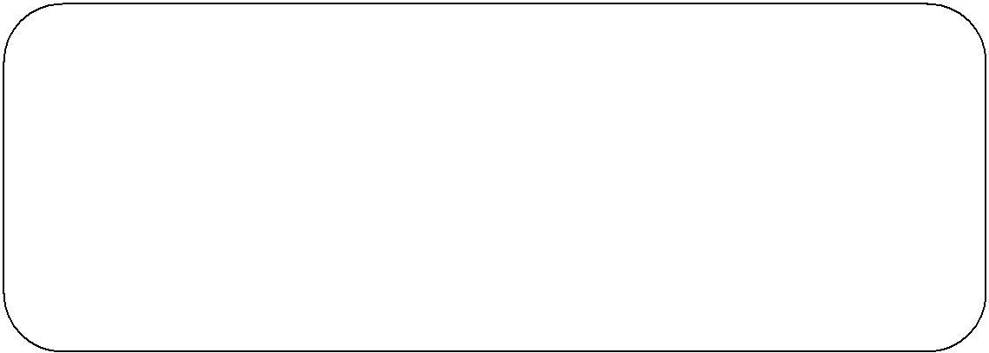To deleted the last node find the last node. find the node using following code
structdnode<T>*pr,*cr; pr=cr=head;
while(cr->next!=NULL)
{pr=cr; cr=cr-
>next; }
pr->next=NULL;
cout<<"dnode"<<cr->data<<"Deletionissucess"; delete(cr);

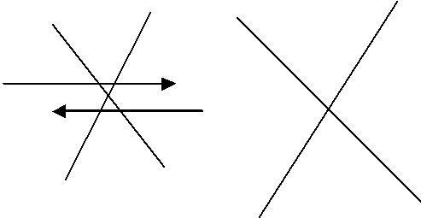head
10
NULL
20
NULL
30
NULL
cr

pr

Code for deleting a node at end of the list:
template<classT>
void dlist<T>::delete_end()
{
structdnode<T>*pr,*cr; pr=cr=head; if(head==NULL)
cout<<"Listis Empty\n";
else
{cr=pr=head;if(head-
>next==NULL)
{

}
else
cout<<"dnode"<<cr->data<<"Deletionis sucess"; delete(cr);
head=NULL;

{
while(cr->next!=NULL)
{
pr=cr;
cr=cr->next;
}
pr->next=NULL;
cout<<"dnode"<<cr->data<<"Deletionissucess"; delete(cr);
}
}
}

CASE3.Delete a node at a given position
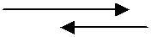
head
 | 20 | NULL

30

NULL | 10

Delete node at position 2
Head is the pointer variable which contains address of the first node.Node to be deleted is node containing value 30.
Finding node at position2.

while(count<pos)
{pr=cr; cr=cr-
>next; count++;
}
pr->next=cr->next; cr->next->prev=pr;
head
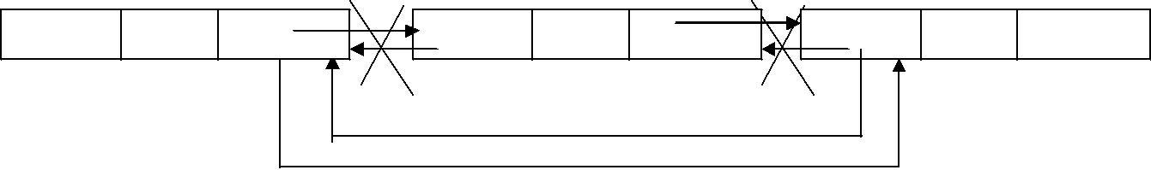
NULL
10
30
20
NUL L
cr
pr

Example for DLL

#include <iostream>
using namespace std;

// Node structure for Doubly Linked List
struct Node {
int data;
Node* prev;
Node* next;

Node(int value) {
data = value;
prev = nullptr;
next = nullptr;
}
};

// Doubly Linked List Class
class DoublyLinkedList {
private:
Node* head;
Node* tail;

public:
// Constructor
DoublyLinkedList() {
head = nullptr;
tail = nullptr;
}

// Insert at the beginning
void insertAtBeginning(int value) {
Node* newNode = new Node(value);
if (!head) {
head = tail = newNode;
return;
}
newNode->next = head;
head->prev = newNode;
head = newNode;
}

// Insert at the end
void insertAtEnd(int value) {
Node* newNode = new Node(value);
if (!head) {
head = tail = newNode;
return;
}
tail->next = newNode;
newNode->prev = tail;
tail = newNode;
}

// Delete a node by value
void deleteNode(int value) {
if (!head) return; // Empty list

Node* temp = head;

// If head node is to be deleted
if (head->data == value) {
head = head->next;
if (head) head->prev = nullptr;
delete temp;
return;
}

// Searching for the node to delete
while (temp && temp->data != value) {
temp = temp->next;
}

if (!temp) return; // Value not found

// If node is tail
if (temp == tail) {
tail = tail->prev;
tail->next = nullptr;
delete temp;
return;
}

// If node is in the middle
temp->prev->next = temp->next;
temp->next->prev = temp->prev;
delete temp;
}

// Display list forward
void displayForward() {
Node* temp = head;
while (temp) {
cout << temp->data << " <-> ";
temp = temp->next;
}
cout << "NULL" << endl;
}

// Display list backward
void displayBackward() {
Node* temp = tail;
while (temp) {
cout << temp->data << " <-> ";
temp = temp->prev;
}
cout << "NULL" << endl;
}

// Destructor to free memory
~DoublyLinkedList() {
Node* temp;
while (head) {
temp = head;
head = head->next;
delete temp;
}
}
};

// Main Function
int main() {
DoublyLinkedList dll;

// Insert elements
dll.insertAtBeginning(10);
dll.insertAtBeginning(5);
dll.insertAtEnd(20);
dll.insertAtEnd(30);

// Display list forward and backward
cout << "Doubly Linked List (Forward): ";
dll.displayForward();

cout << "Doubly Linked List (Backward): ";
dll.displayBackward();

// Delete a node
dll.deleteNode(20);
cout << "After deleting 20: ";
dll.displayForward();

return 0;
}
Real-time applications of Linked Lists
Linked lists in C++ are used in various real-time applications where dynamic memory allocation, efficient insertions and deletions, and flexible data structures are required.
The following are the real-time applications of Linked Lists:

1. Memory Management
- Operating systems use linked lists to manage free and allocated memory blocks.
- The heap memory allocator (e.g., malloc and free) often utilizes linked lists to track memory blocks.

2. Undo/Redo Functionality
Applications like text editors (Notepad, Word, etc.) use linked lists to implement undo/redo operations by maintaining a history of changes.

3. Browser's Forward and Backward Navigation
Doubly linked lists help implement the forward and backward navigation system in web browsers.

4. Music and Video Playlists
Circular linked lists are used to maintain playlists where users can move forward and backward seamlessly.

5.Graph Implementations (Adjacency List)
Many graph algorithms use linked lists to store adjacent nodes, making traversal and operations more efficient.

6. Hash Tables (Chaining for Collision Handling)
Linked lists are used in hash tables to handle collisions using separate chaining.

7. Implementation of Stack and Queue
Linked lists are used to implement dynamic stacks and queues without the need for resizing, unlike arrays.

8. File System Directory Management
Operating systems use linked lists to organize file directory structures (e.g., hierarchical file systems).

9. Social Media Feeds
Platforms like Facebook, Twitter, and Instagram use linked lists to maintain dynamic news feeds.

10. Polynomial Arithmetic
Polynomial representation and operations (addition, multiplication) use linked lists to store and manipulate coefficients and exponents efficiently.

